**Pengenalan RESTful API**

1. <https://jsonplaceholder.typicode.com/posts>

GET

Mendapatkan semua data post

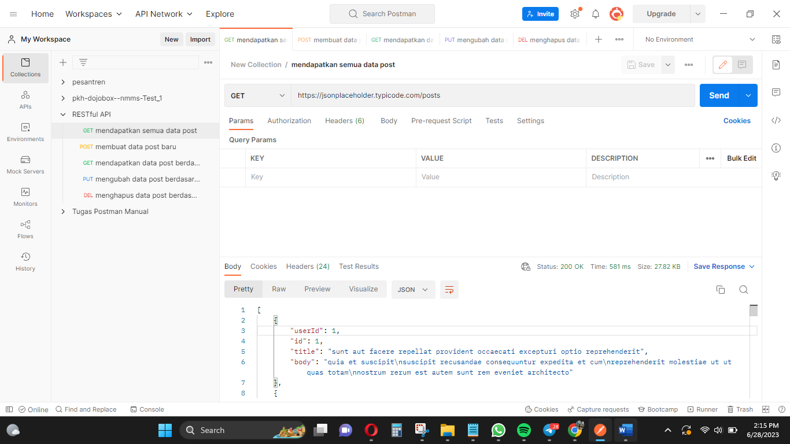

1. <https://jsonplaceholder.typicode.com/posts>

POST

Membuat data post baru

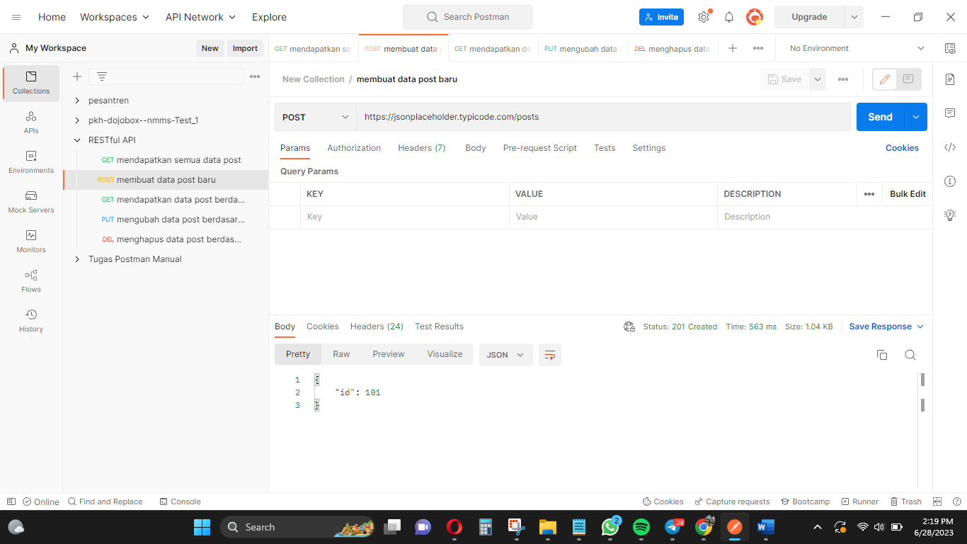

1. <https://jsonplaceholder.typicode.com/posts>

GET

Mendapatkan data post berdasarkan ID

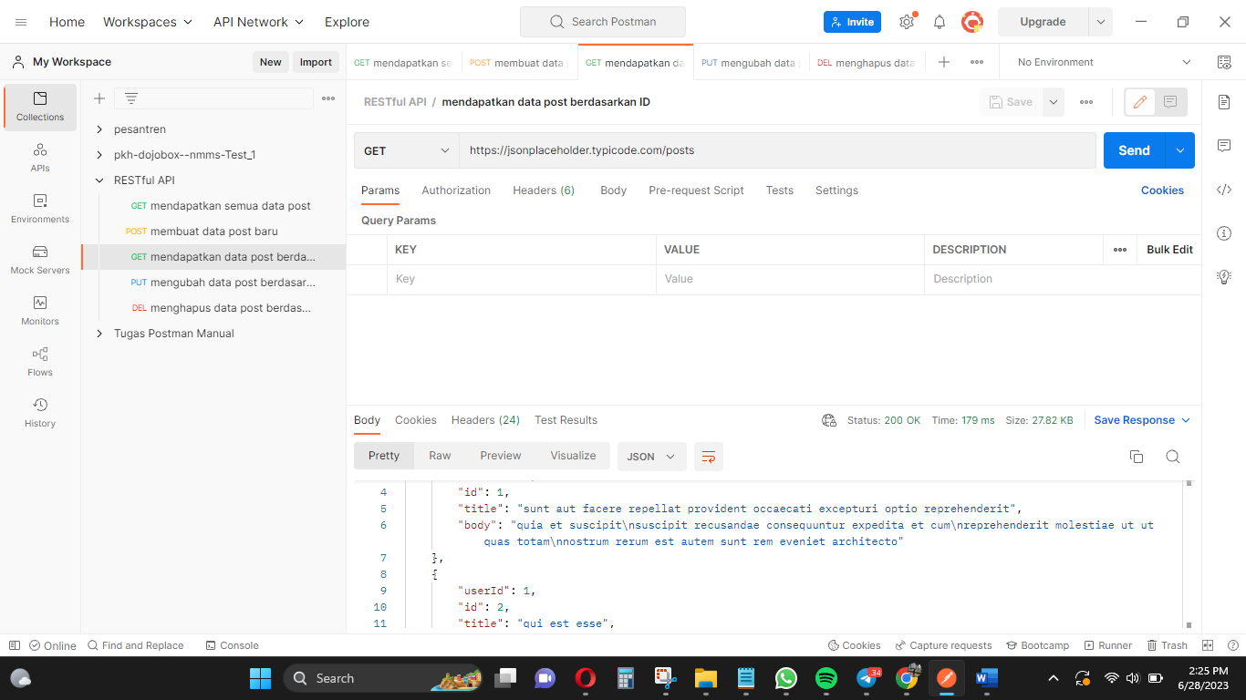

1. <https://jsonplaceholder.typicode.com/posts/1>

PUT

Mengubah data post berdasarkan ID

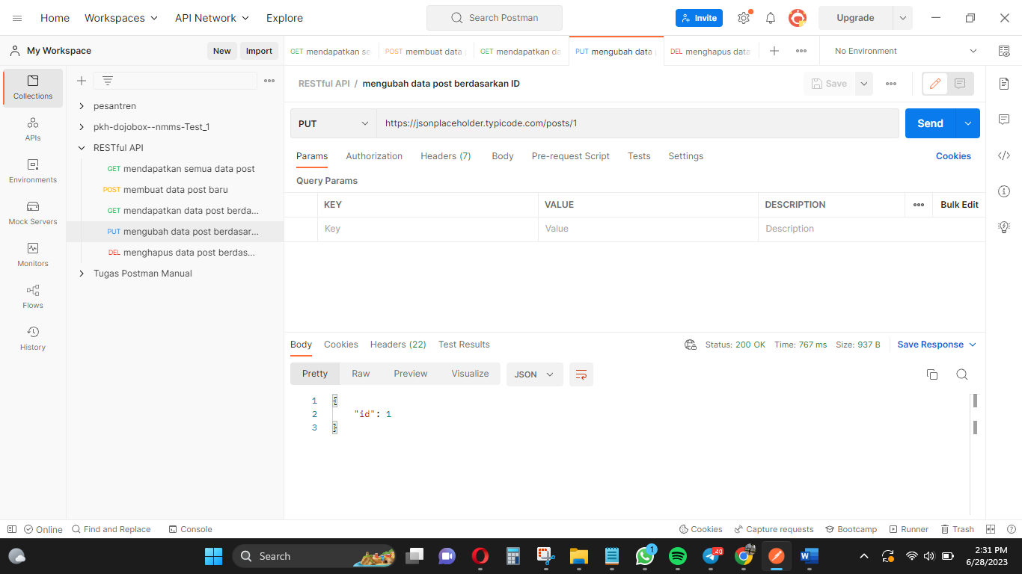

1. <https://jsonplaceholder.typicode.com/posts/1>

DELETE

Menghapus data post berdasarkan ID

